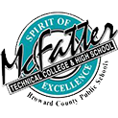

**School Advisory Forum Meeting**

**Thursday, December 1, 2022 - 1:00 pm**

**Location: McFatter Technical High School**

Agenda

1. Call to Order
2. New Business
   1. We are now a part of the Central Area Advisory Council ([website](http://centralareaadvisorycouncil.ch2v.com/))
3. Old Business
   1. Central Area Advisory Council Updates
   2. Next CAAC Meeting
4. Adjourn